Job Description: | Elevated Work Platform |  |  | Date: | 6-2-26 | Risk Rating: Medium
Name, & Contact Details:  Robertson’s Remedial and Painting Pty Ltd  Unit 10/56 Buffalo Road  Gladesville NSW 2111  Phone: (02) 9181 3519  A.B.N 16 140 746 247 |  |  |  | Site Location:  3 Palm Ave Breakfast Point
Name & Phone Number of Person Completing SWI: Alan Richardson 0417238448
Name & Phone Number of the Person Supervising the Work: Nick Vuckovic 0477 990 002
Comments; This Safe Work Instruction (SWI) is to be used in conjunction with the Safe Work Method Statement for the task being performed. Operating instructions from the supplier of plant are to be obtained and followed.
Procedure  (In Steps): | Possible Hazards: | Risk Score | Safety Controls: |  |  |  | Residual Risk | Responsible Person
Planning for the setup of EWP | Untrained or unlicensed workers may access site | Medium  (3) | All workers must have a Construction Induction Certificate.  All workers must complete site induction upon arrival to site and sign in.  Where induction is not available workers to liaise with site controller about site hazards, emergency procedures and any other site requirements.  All workers to be trained in and sign safe work method statement.  All workers to be qualified/ licensed/ ticketed/ trained as required for activities  Operator to be familiar with the manufacturers operating instructions prior to operating machine, operator to refer to logbook on machine and conduct “Operator Daily Safety Checks”.  Toolbox talk to be conducted prior to commencement of works  All workers to be in a fit state to commence work, be Zero blood alcohol concentration, not be suffering from fatigue or under the influence of drugs  For all work over 11m operators must hold a current certificate of competency |  |  |  | Low  (2) | Workers and Supervisor
Procedure  (In Steps): | Possible Hazards: | Risk Score | Safety Controls: |  |  |  | Residual Risk | Responsible Person
Planning for the setup of EWP | Inappropriate tool and equipment allocation | Medium  (3) | Risk Assessment of site to be carried out prior to commencement of work.  Management to ensure adequate workers numbers are allocated to complete work.  Management to ensure adequate personal protective equipment is available  Management to ensure that appropriate equipment and procedures are used for the works being completed.  Management to ensure that all equipment has been inspected, maintained, certified. |  |  |  | Low  (2) | Workers and Supervisor
Accessing the site | Slips, trips and falls | Medium  (3) | All workers to wear approved rubber sole work boots as per AS/NZS 2210.  Onsite inductions to be completed prior to entering the job including identification of any slip trip and fall hazards. All workers to be aware of risk management procedures to ensure they can identify, assess and control all trip hazards.  Competent person to supervise all new workers.  Workers not to access areas where risk of slip trip or fall is present.  Approved safety vests, hard hats and safety glasses to be worn at all times. |  |  |  | Low  (1) | Workers and Supervisor
Accessing the site | UV radiation exposure | Medium  (3) | Workers must wear appropriate PPE including: sun cream, sun hats, long sleeve shirts, and sunglasses while working outside.  Workers must remain hydrated through regularly drinking water.  Workers to stay out of sun where possible and implement rest breaks or job rotation where necessary.  Workers to consider stopping work in extreme heat. |  |  |  | Low  (1) | Workers
Secure job site to ensure unauthorised personnel do not access | Unauthorised individuals entering work site | Medium  (3) | Where necessary work area to be barricaded to prevent unauthorised access.  Spotter to observe personnel and re direct as needed and when safe to do so.  Alternate access to be provided where appropriate.  Equipment to have flashing lights and reverse beacons activated |  |  |  | Low  (2) | Workers
Procedure  (In Steps): | Possible Hazards: | Risk Score | Safety Controls: |  |  |  | Residual Risk | Responsible Person
EWP/equipment delivery | Traffic hazard  Collision with vehicles | Medium  (3) | Competent ticketed person to redirect traffic as necessary.  Approved high visibility uniforms or vests as per AS/NZS 1716 to be worn at all times.  Supervisor to monitor traffic movements |  |  |  | Low  (2) | Workers and Supervisor
EWP/equipment delivery | Manual handling | Medium  (3) | Workers to follow correct manual handling procedures:  Only lift objects within your safe lifting limit (use team lifts where needed)  Clear a path, assess the load, get a good grip, ensure a wide stance, bend the knees, keep the spine strait, use the legs to lift, do not twist the trunk, use a smooth action, brace the stomach muscles and lower safely. |  |  |  | Low  (2) | Workers
Pre-inspection of EWP and work area | Not completing pre-start checklist. Workers not informed of hazards | Medium  (3) | Daily Pre-start Checklists to be completed and logged & signed by operator  Complete tool box talk and sign SWI  View Traffic Control Plan and permits as required  Set up EWP in accordance with manufacturer’s recommendations |  |  |  | Low  (2) | Workers and Supervisor
Set up EWP | Persons being struck by EWP | Medium  (3) | Only trained and competent workers to operate EWP  EWP to be equipped with audible and visual alarms when travelling  Approved safety vests to be worn at all times.  Use additional spotter where necessary  Ensure clear communication between workers and EWP operator  Barricade area from public access  Ground workers to remain clear of moving plant |  |  |  | Low  (2) | Workers and Supervisor
Set up EWP | Machine failure causing injury to workers and surrounding persons | Medium  (3) | Set up EWP in accordance with manufacturer’s recommendations  Daily maintenance check of function and operation safety  Only trained and competent workers to be involved in operating & maintaining plant  Supervision to be provided to all new workers  Park machine on hard ground at all times.  Operator to set up machine to AS2550.5-2002 Manufacturers manual & specs  Machine level & clear of excavation or embankment i.e. outside of slip zone |  |  |  | Low  (2) | Workers and Supervisor
Procedure  (In Steps): | Possible Hazards: | Risk Score | Safety Controls: |  |  |  | Residual Risk | Responsible Person
Set up EWP | EWP tipping or rolling | Medium  (4) | Prior to operation, inspect the entire work site and all ground conditions where the EWP will travel.  Do not exceed maximum weight capacity of machine.  Do not drive when elevated.  Do not use, elevate or leave elevated in high winds that exceed the machines maximum wind rating.  Do not attach sail hazards such as signs, banners, shade cloth etc. to the EWP, and exercise caution when carrying large surface area materials in the EWP e.g. roofing sheets and plasterboard etc. as this will increase the exposed wind area of the machine and may cause the plant to tip over in windy conditions.  Do not perform work that will subject the EWP to a side force greater that the machines rated side loading e.g. pushing and pulling on a fixed structure when working from a EWP.  If one or more of the wheels are not making full contact with the ground exercise extreme caution.  Fully lower the EWP and position machine so all wheels are in full contact with the ground. |  |  |  | Low  (2) | Workers
Set up EWP | Contact with overhead power lines, infrastructure or persons | High  (9) | Complete survey of site with before entering and plan path of travel to ensure all obstacles are avoided.  Approved Uniform with high visibility to be worn at all times.  Spotter to be used to ensure EWP remains safe distance from power lines.  Ensure clear communication between workers and workers.  Barricade area from public access  Ground workers to remain clear of moving plant.  Operator to stay alert and maintain safe distance from persons/structures  EWP to operate safe distances from electrical services, infrastructure and people at all times as per AS2550.5-2002  - 3m clearance up to 132,000V  - 6m clearance 132,000V to 330,000V  - 8m + clearance for over 330,000V |  |  |  | Low  (2) | Workers
Procedure  (In Steps): | Possible Hazards: | Risk Score | Safety Controls: |  |  |  | Residual Risk | Responsible Person
Drive EWP into position | Contact with overhead powerlines and electricity causing electrocution | High  (9) | Electrical Distances Noted as Per AS 2550.1  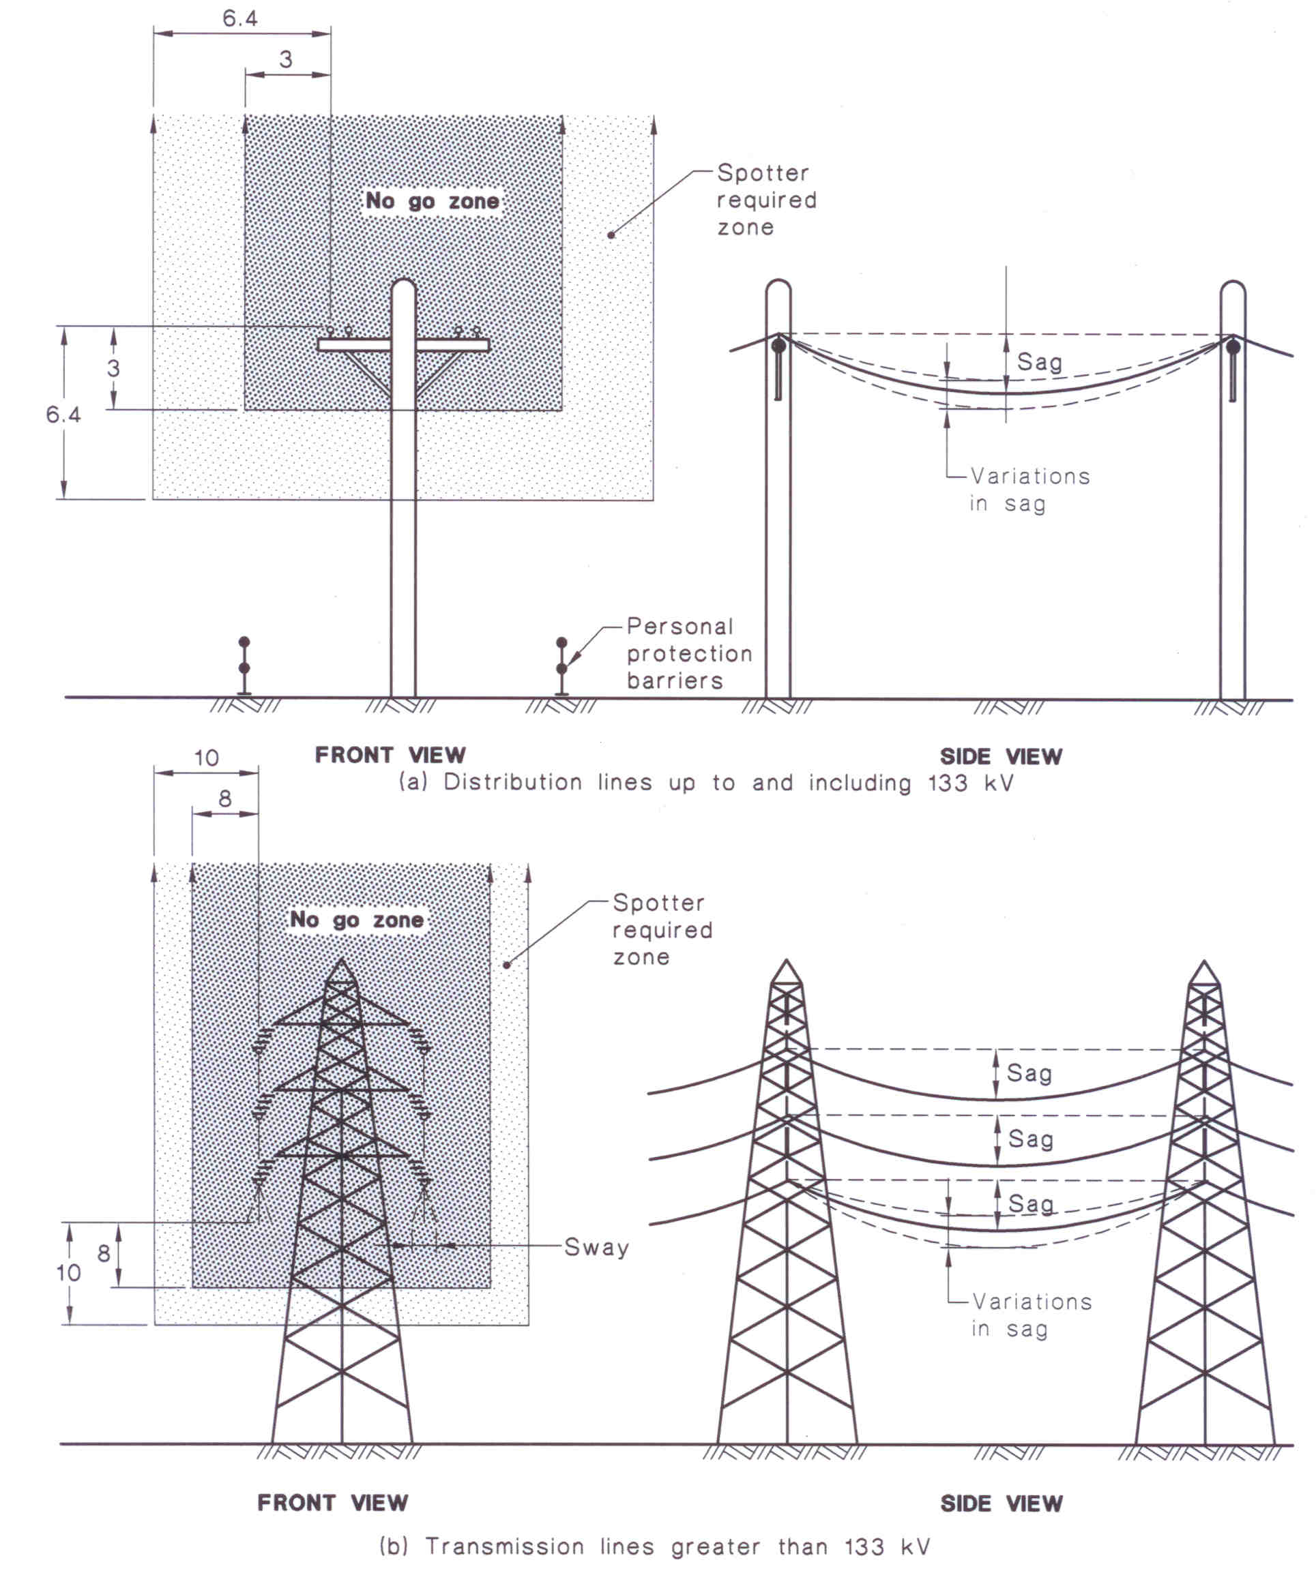 |  |  |  | Low  (2) | Workers
Operate  EWP | Individuals may be crushed when lowering or raising EWP | High  (6) | Operator must ensure that all personnel are cleared from the area prior to raising or lowering the EWP.  Keep hands and body parts clear of moving machinery. |  |  |  | Low  (2) | Workers and Supervisor
Procedure  (In Steps): | Possible Hazards: | Risk Score | Safety Controls: |  |  |  | Residual Risk | Responsible Person
Operate  EWP | Parts of the plant collapsing | Medium  (3) | Ensure no personnel work through EWPs or underneath any part of the EWP. Never walk or work under raised hydraulics. |  |  |  | Low  (2) | Workers
Operate  EWP | Being trapped between the plant and materials or fixed structures | Medium  (3) | Avoid congested work areas.  Remain within the confines of the EWP while operating  Ensure sufficient clearance between the EWP and overhead obstacles.  Always wear a hard hat where overhead hazards are present |  |  |  | Low  (2) | Workers
Operate  EWP | Body parts may become entangled in moving parts | High  (6) | Ensure work area is secure  Keep personnel clear of moving parts.  Do not wear loose fitting clothing  Awareness of operator/ other associated personnel- do not put body parts or limb through or between EWP arms unless absolutely necessary and safety locks are correctly in place.  Operator to ensure that work area is clearly defined and barricaded. |  |  |  | Low  (2) | Workers
Operate  EWP | Exposure to inclement weather | Medium  (3) | Do not operate EWP in bad weather e.g. high winds heavy rain or lighting. |  |  |  | Low  (2) | Workers and Supervisor
Operate  EWP | Tools or material may fall from platform | Medium  (3) | Operator must ensure that the work area is appropriately barricaded off to prevent unintended access.  Keep all tools and objects secure in the platform. |  |  |  | Low  (2) | Workers
Operate  EWP | Falling from platform | Medium  (4) | Remain within confines of lift platform. Never sit, stand or climb on handrail. Workers to use a fall arrest system if appropriate.  Do not use or elevate platform if guard rails have been removed (may have been removed when transporting into tight locations).  Never use ladders or scaffolding on the platform.  Never enter or exit the platform when elevated unless appropriate controls are in place as outlined in enter and exit basket. |  |  |  | Low  (2) | Workers
Operate  EWP | Poor floor or working surface | Medium  (3) | Ensure floor is kept clean, in good condition and intact. Avoid oil grease and mud on boots.  Maintain good foot and hand hold when climbing in or out of platform. |  |  |  | Low  (1) | Workers
Procedure  (In Steps): | Possible Hazards: | Risk Score | Safety Controls: |  |  |  | Residual Risk | Responsible Person
Operate  EWP | Slipping and falling off scissor if standing on external components to gain better access | High  (6) | Never stand on rails and do not over reach  Ensure steps and support surfaces are clean in good condition and intact. Avoid oil grease and mud on boots.  Always maintain good foot and hand holds when climbing on or off the scissor, any solid construction or fall prevention equipment. |  |  |  | Low  (2) | Workers
ntering or exiting basket when elevated | Fall from heights | High  (6) | Workers to enter and exit basket only when the following conditions are met:  - Risk assessment shows that this is safer than all other means of access  - The structural adequacy of the landing has been established and the landing area is clear.  - The risk of falling from the landing area is considered and controlled.  - The EWP must reach 1.2 times further than the required height.  - The floor of the EWP can be lowered within 300mm of the landing  - The basket must be at least 2m from the edge unless a harness attached to suitable anchorage is to be used (where the height is over 2m)  - Where the basket is adjacent to the surface the gap must not be more than 100mm. and a harness must be worn attached to anchor point.  - The base controls are tagged to indicate the equipment is in use and to caution against movement.  Deflection when entering or leaving must be considered and allowed for.  If the following conditions are not met, workers must not enter or exit the basket at height. |  |  |  | Low  (2) | Workers
Lower EWP | Lowering EWP onto personnel causing serious injury | High  (6) | Approved safety vests to be worn at all times.  Lower basket slowly  All personnel to remain clear of boom  Provide adequate warning of descending load to persons below  Do not place hand or bodily parts below the basket when lowering |  |  |  | Low  (2) | Workers
Procedure  (In Steps): | Possible Hazards: | Risk Score | Safety Controls: |  |  |  | Residual Risk | Responsible Person
Packing up EWP | Plant tipping or rolling over when unattended | High  (6) | Do not leave the EWP elevated and unattended as it could be exposed to excessive wind loads and other risks such as collision with vehicles.  If EWP must be left elevated and unattended (security reasons) it must be assessed as safe to do so and the EWP must not be raised more than one third of its full extension height. |  |  |  | Low  (2) | Workers and Supervisor
Packing up EWP | Unauthorised persons accessing and using EWP when unattended | Medium  (4) | Lock all cabinets and covers when leaving machine unattended.  Power supply isolated where applicable  Motion brakes and locks to be applied.  Remove key from ignition |  |  |  | Low  (2) | Workers
Packing up EWP | Persons being struck by moving plant | High  (6) | Only trained and competent workers to operate EWP  EWP to be equipped with audible and visual alarms when travelling  Approved safety vests to be worn at all times.  Use additional spotter where necessary  Ensure clear communication between workers and EWP operator  Barricade area from public access  Ground workers to remain clear of moving plant |  |  |  | Low  (2) | Workers
Refuelling EWP | When refuelling, sparks, flames, hot engine can ignite fuel | High  (6) | Shut down engine prior to refuelling.  Prior to filling ground nozzle against tank to avoid spark.  Refuel in a well-ventilated area.  Ensure that there are no naked flames in the area.  Do not smoke, avoid spilling fuel and collect any fuel run off.  Do not refuel when EWP is elevated. |  |  |  | Low  (2) | Workers
Refuelling EWP | Injury to workers, exposure to chemicals | Medium  (3) | Ensure EWP is switched off  No smoking in vicinity on EWP  Ensure correct PPE is worn at all times when refuelling.  Ensure spill kit is kept on site  Any spills to be cleaned immediately  Ensure current Safety Data Sheet is present on site at all times for the safe use of petrol/diesel. |  |  |  | Low  (2) | Workers
Procedure  (In Steps): | Possible Hazards: | Risk Score | Safety Controls: |  |  |  | Residual Risk | Responsible Person
Clean-up site | Housekeeping | Medium  (3) | All tools and equipment to be secured at all times.  Secure off work area below and above  Hard hats must be worn at all times.  Only trained and competent workers to be used.  Centralise and store all tools and equipment at designated secured storage areas.  Clean work area and dispose of waste and debris. |  |  |  | Low  (2) | Workers
Clean-up site | Hazardous Manual | Medium  (4) | Workers to follow correct manual handling procedures:  Only lift objects within your safe lifting limit (use team lifts where needed)  Clear a path, assess the load, get a good grip, ensure a wide stance, bend the knees, keep the spine strait, use the legs to lift, do not twist the trunk, use a smooth action, brace the stomach muscles and lower safely. |  |  |  | Low  (2) | Workers

Personal Protective Equipment (PPE) required: | Enclosed leather steel capped boots Safety Glasses (As per AS/NZS 1336) | Hearing protection (As per AS/NZS 1269)  Padded gloves (As per AS/NZS 2161)
Training and Qualifications required by workers to complete the work: | General Construction induction Training  Induction into SWI | HRW Licence EWP boom length greater than 11m  Certificate of competency required to operate EWPs
List the Permits, Certificates, SafeWork NSW Approvals, required to complete the work:
Relevant legislation:  For further details refer to the Legal Requirements Register | Work in accordance with Work Health and Safety Act 2011 and Work Health and Safety Regulation 2017, safety data sheets located with site supervisor, workplace injury management and workers compensation act 1998, Workers Compensation Regulation 2016, AS/NZS1337.1 Personal eye protection-Eye and face protectors for occupational applications (2010), AS/NZS 1269.3 Occupational Noise management-Hearing protection program (2005), AS/NZS 1801 industrial safety helmets (1997), AS/NZS 2210.1 Safety, protective and occupational footwear-Guide to selection, care and use (2010) & AS/NZS 2210.2 to 2210.9 Occupational protective footwear, 4.2.2: Fall Prevention; 4.3.6: Working at heights; 5.4: Working with Plant AS 2550.10 EWP’s, hoists and winches – Safe use Part 10: Safe Use of Work Baskets, AS/NZS 2550.10 Cranes, hoists and winches- Safe use- Mobile elevating platforms. Safety (2006)  Data Sheets for Petrol/Diesel  Safe Work Australia Codes of Practice  - Construction Work  - Work Health and Safety Consultation, Co-operation and Co-ordination  - Managing the Work Environment and Facilities  - First Aid in the Workplace  - Hazardous Manual Tasks  - Managing Noise and Preventing Hearing Loss at Work  - How to manage Work Health and Safety Risks
Hazardous Substances | Petrol/diesel
Plant/equipment that will be used on site:  Maintenance checks for plant & equipment: | Elevated Work Platform  Daily pre-start checks of EWP, Safety Harness (where required), servicing as per manufacturer’s instructions
Frequency of site/workplace inspections: | Daily by site supervisor
The control measures implemented will be reviewed in consultation with workers and or others who may be affected by the SWI. Any changes to the SWI will be communicated with workers at induction, daily pre-starts and toolbox talks.

Sign Off and Approvals

Person responsible for site supervision of the work, inspecting and approving work areas, approval of and compliance with SWI, protective measures, plant, equipment:
Name and position: | Signature:
SWI Prepared by: Alan Richardson | Signature:

Risk Level | Description of consequence or impact | Consequence | Likelihood/Probability
Risk Level | Description of consequence or impact | Consequence | Unlikely (1) | Possible (2) | Almost Certain (3)
High  Level of harm | Actual/Potential fatality, disability or irreversible damage. Major structural failure/damage. Off-site environmental discharge/release not contained and significant long-term environmental harm. | Major (3) | Medium  (3) | High  (6) | High  (9)
Medium  Level of harm | Actual/Potential temporary disability, MTI or LTI. Structural failure/damage, >1-day outage. On-site environmental discharge/release contained, minor remediation, short-term environmental harm. | Moderate (2) | Low  (2) | Medium  (4) | High  (6)
Low  Level of harm | Incident that has the potential to cause persons to require first aid. Environmental discharge/release immediately contained, minor level clean-up with no short term environmental harm. | Minor (1) | Low  (1) | Low  (2) | Medium  (3)
Level | Likelihood/Probability
Almost Certain | Occurs frequently; >66% chance of occurring
Possible | Could happen occasionally; >33% but <66% chance of occurring
Unlikely | May occur only in exceptional circumstances; <33% chance of occurring
Class/Ranking | Description/Requirements
High 6, 9 | Stop immediately. Implement permanent preventative controls.
Medium 3, 4 | Will require operational planning. Actions will be recorded on a SWI.
Low 1, 2 | Will require detailed pre-planning. Actions will be recorded on a SWI. Will require localised control measures.

SWI has been developed using the hierarchy of controls to reduce the risk and likely hood of an incident/injury occurring. The use of Elimination, Substitution,
Engineering/isolation, Administrative and PPE measures will be used in the above order of preference wherever practicable.

Induction confirmation:

This SWI has been developed in consultation with the workers and has been read and signed by all workers involved in this activity. I note that I have read and understood the above safe work instruction and will ensure work is completed accordingly.

Date: | Name: | Signature:

